Chapter 7, Solution 45.

To find R_{Th}, consider the circuit shown below.

20 kΩ 10 kΩ

40 kΩ R_{Th}

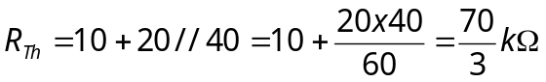
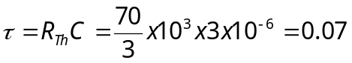

To find 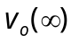, consider the circuit below.

20 kΩ 10 kΩ
+
_

+
30V
40 kΩ v_{o}

–

v_{o}(∞) = [40/(40+20)]30 = 20 V

v_{o}(t) = v_{o}(∞) + [v_{o}(0)– v_{o}(∞)]e^{–t/0.07} = [20 –15e^{–14.286t}]u(t) V.

